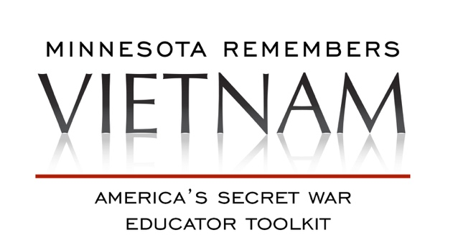

**Activity Guide for Secondary Social Studies: Migration**

**This activity guide was created for use with middle school students**

**but can be modified for other levels.**

**Activity Guide Outline:**

1. Geography of Southeast Asia
2. Migration of the Hmong: Laos to Thailand
3. The Refugee
4. Migration of the Hmong: Thailand to America
5. Your Migration Story

**View the film America’s Secret War**Show the film [Minnesota Remembers Vietnam: America’s Secret War](https://www.tpt.org/americas-secret-war/), and have students fill in answers to the viewing guide. <https://goo.gl/a17tPD>

**America’s Secret War**

In the shadows of the Vietnam War, the CIA conducted a secret war in Laos that relied on Hmong soldiers to prevent the threat of communism from spreading deeper into Southeast Asia. Tens of thousands died, both in the fight and in the escape. **America’s Secret War** explores the untold, turbulent history. :60 documentary produced by Twin Cities PBS for the *Minnesota Remembers Vietnam* initiative.

**Geography of Southeast Asia**

**Essential Question**

What are the human and physical features of Southeast Asia?

**Supporting Questions**

* Why are the human and physical features of Southeast Asia important to the story of the Secret War and the Vietnam War?
* How did the landscape differ from the landscape in Minnesota? What are the similarities?
* What is the Ho Chi Minh Trail and what role did it play in the war?

**Resources/Materials**

* America’s Secret War Digital Shorts
  + **Domino Theory**   
    The Red Scare played a huge role in the Vietnam War and the lesser known Secret War, waged concurrently in neighboring Laos. President Dwight D. Eisenhower feared that if Laos fell to Communism, the entire Eastern Hemisphere would become a threat to democracy. To secure the Vietnamese border, the CIA recruited Hmong people to fight as surrogate soldiers of the U.S. armed forces.

[https:/www.mnvietnam.org/story/history-of-the-domino-theory](https://www.mnvietnam.org/story/history-of-the-domino-theory)

* + **The CIA, the Hmong and the Secret War**

Hmong General Vang Pao, a courageous and powerful leader, worked in tandem with the CIA to conduct covert operations in Laos. Among the hardest hit by this “Secret War” were the Hmong of northern Laos. Tens of thousands were killed during the war, and even more lost their lives while attempting to escape to freedom after the war ended.   
[https:/www.mnvietnam.org/story/the-cia-the-hmong-and-the-secret-war](https://www.mnvietnam.org/story/the-cia-the-hmong-and-the-secret-war)

* TODALS Poster Map:
  + Large poster paper
  + Sample map of Southeast Asia - **Handout A**
  + Coloring materials

**Activities**

1. **Watch America’s Secret War Digital Shorts:** [Domino Theory](https://www.mnvietnam.org/story/history-of-the-domino-theory), [The CIA, the Hmong and the Secret War](https://www.mnvietnam.org/story/the-cia-the-hmong-and-the-secret-war)

**Discussion Questions:**

* 1. What was the Domino Theory?
  2. Why Laos?
  3. How did the Hmong get involved in the war?

1. **TODALS Poster Map of SE Asia:** Students will create a poster map of Southeast Asia. The map must include all the elements of TODALS. Instructor models a map with all the elements of TODALS. Instructor to provide sample maps of Southeast Asia. (Handout A or use Google Maps)
   1. **T**itle
   2. **O**rientation
   3. **D**ate
   4. **A**uthor
   5. **L**egend
   6. **S**cale
2. **5-Themes of Geography Slideshow:** Students will create a slideshow presentation on Southeast Asia or a specific country in SE Asia (Laos, Vietnam, Thailand) using the 5-Themes of Geography.
   1. Location
   2. Place
   3. Region
   4. Movement
   5. Interaction
3. **Mapping Southeast Asia**
   1. **Easy -** Students locate on a map that is prelabeled (blank spaces where the locations are). Instructor provides actual maps to assist students to locate places on the blank maps. Visit Google Maps.   
      Placeholder Map: <https://www.enchantedlearning.com/asia/laos/outlinemap/>
   2. **Advanced -** Students locate political boundaries and physical features using coordinates (Latitudes & Longitude) and map them on a blank map of Southeast Asia, including latitude and longitude. Students should be directed to add additional physical features to the grid below and to the blank map of Southeast Asia.

**For Advanced Map**

|  |  |
| --- | --- |
| **Political Boundaries** *(Cities, Countries)* | **Physical Features** *(Mountains, Rivers)* |
| 1. Laos 2. North Vietnam 3. South Vietnam 4. Thailand 5. Ho Chi Minh City 6. Saigon 7. Vientiane 8. Long Cheng 9. 17th Parallel 10. Ho Chi Minh Trail | 1. Mekong River |

**Migration of the Hmong: Laos to Thailand**

**Essential Question**

What are the push factors that forced the Hmong out of Laos and into the Refugee camps of Thailand?

**Supporting Questions**

* What does it mean to have a homeland?
* How does migration and/or place affect one’s identity?
* How was the migration to Thailand worse for the Hmong than the actual war?

**Resources/Materials**

* America’s Secret War Digital Shorts
  + **Digital Short:** **Khou Yang - Wrenching Choices in Times of War**At the end of the Secret War, Hmong women and children often surrendered to the Pathet Lao—but trying to survive in Communist villages meant living in constant fear and being faced with difficult choices. Khou Yang was newly pregnant, a sure sign that her husband was hiding in the nearby jungle. She feared that the Pathet Lao would hunt down and kill her husband if her pregnancy was discovered.  
    <https://www.mnvietnam.org/story/khou-yang-wrenching-choices-in-times-of-war/>
  + **Digital Short: Dr. Mai Na Lee Escapes the Communist Pathet Lao**

As the Secret War ended, Hmong who fought on the side of the United States were hunted by Communist Pathet Lao soldiers in their native Laos. Dr. Mai Na Lee and her family were among the many people who fled the country, eventually swimming across the wide and fast-flowing Mekong River into Thailand’s refugee camps.

<https://www.mnvietnam.org/story/dr-mai-na-lee-escapes-the-communist-pathet-lao/>

* [Thai Refugee Camp map](https://www.mnvietnam.org/content/uploads/2019/02/Refugee_Camps_Thailand_Map_v1.jpg) from America’s Secret War **– Handout B**
* Hmong Story Cloth:
  + Images of Hmong story cloths: <http://www.hmongembroidery.org/embroideryfarmingvillagelifeandwar.html>
  + **Project Paj Ntaub featuring Suzanne Thao**The Hmong Museum's longest running program, Project Paj Ntaub, is a space for intergenerational communities to gather together and learn the art of paj ntaub.   
    <https://www.youtube.com/watch?v=ao2f4KkXaf8>
  + Construction paper
  + Coloring materials
  + Sewing supplies, optional

**Activities**

1. **Watch America’s Secret War Digital Shorts:** [Khou Yang - Wrenching Choices in Times of War](https://www.mnvietnam.org/story/khou-yang-wrenching-choices-in-times-of-war/), [Dr. Mai Na Lee Escapes the Communist Pathet Lao](https://www.mnvietnam.org/story/dr-mai-na-lee-escapes-the-communist-pathet-lao/)

**Discussion Questions:**

* + 1. What were the Push factors that forced Hmong migration into Thailand?
    2. What does it mean to have a homeland?
    3. How does migration and/or place affect one’s identity?
    4. How was the migration to Thailand worse for the Hmong than the actual war?

1. **Students demonstrate their learning about the Hmong escape to Thailand through visual storytelling by creating a Hmong Story Cloth**
2. Provide background about Hmong story cloths (Paj Ntaub – pronounced “pan dow”) by showing the Hmong Museum’s video [Project Paj Ntaub featuring Suzanne Thao](https://www.youtube.com/watch?v=ao2f4KkXaf8) and [images of Hmong Story Cloths](http://www.hmongembroidery.org/embroideryfarmingvillagelifeandwar.html).
3. Students will create a Hmong story cloth with paper and markers/crayons about Hmong migration from Laos to Thailand.
4. Students share their story cloths with the class and explain what they included.

* **Additional reference:** Cy Thao’s art is based on Paj Ntaub:  
  <https://www.mnvietnam.org/story/minnesota-legislator-and-painter-cy-thao/>

**What Does it Mean to be a Refugee?**

**Essential Question**

What does it mean to be a refugee?

**Supporting Questions**

* How are the experiences of refugees (dis)similar to one another?
* Why might that be?

**Resources/Materials**

* America’s Secret War Digital Short: **Growing Up in a Thai Refugee Camp**Children in the refugee camps had to grow up fast. Sia Her shares a few of her formative experiences as a young child in Thai refugee camps.

<https://www.mnvietnam.org/story/growing-up-in-a-thai-refugee-camp/>

**Activities**

1. **Watch America’s Secret War Digital Short:** [Growing Up in a Thai Refugee Camp](https://www.mnvietnam.org/story/growing-up-in-a-thai-refugee-camp/)

Discussion questions:

* Describe living conditions in the Ban Vinai refugee camp. Provide specific examples.
* Although Hmong women's stories are not a major focus in the film, speculate war wounds they may still endure.

1. **Concept Map** - Students will create a concept map about what it means to be a Refugee.

REFUGEE

1. **Refugee Experiences** - Students will answer the following questions:
   1. How are the experiences of refugees (dis)similar to one another?
   2. Why might that be?
2. **Persuasive Essay** - Evaluate/update the words written on the Statue of liberty, “Give me your tired, your poor, Your huddled masses yearning to breathe free, The wretched refuse of your teeming shore. Send these, the homeless, tempest-tossed to me, I lift my lamp beside the golden door!”
   1. How do these words reflect the U.S.’s views towards refugees in past and present?
   2. If you were able to rewrite, or edit the words atop the Statue of Liberty, what would you have it say? Why?

**Migration of the Hmong: Thailand to America**

**Essential Question**

What are the pull factors that made the Hmong immigrate to the United States of America?

**Supporting Questions**

* What are arguments to stay in Thailand/Laos?
* How did Hmong immigrants arrive to the United States? What was the process?

**Resources/Materials**

* **Story Wall Overview:** The Story Wall contains personal accounts from the Secret War in Laos and the War in Vietnam and Southeast Asia. Each story provides a unique perspective from a storyteller who provides insight into the war and its effects on their lives. The interactive map (<https://www.mnvietnam.org/map/>) provides the viewer with a glimpse into where storytellers were during the conflict, and where they are today (or at the time the story was shared).
* **The Latehomecomer**  
  Author Kao Kalia Yang reads from and talks about writing her award-winning book, The Latehomecomer: A Hmong Family Memoir.   
  <https://www.mnvietnam.org/story/kao-kalia-yangs-hmong-memoirs/>
* **Growing Up Hmong: One Woman’s Path** (essay)  
  Kaolee Vang’s personal story about growing up in Minnesota as the daughter of Hmong refugees.<https://www.mnvietnam.org/story/growing-up-hmong-american-one-womans-path/>
* **Graphic Novel Panel**   
  Students will create a graphic novel panel related to the Hmong migration from Laos to Thailand.
  + Graphic Novel Panel Templates Worksheets (2 versions) - Handouts C & D
  + Additional [Graphic Novel/Comic Strip Template downloads](https://www.teacherspayteachers.com/Product/Free-Download-Comic-Strip-Template-Pages-for-Creative-Assignments-149469)
  + [Graphic Novel example (from Thi Bui’s](https://www.vulture.com/2017/03/thi-bui-best-we-could-do-refugee-comic.html) *[The Best We Could Do](https://www.vulture.com/2017/03/thi-bui-best-we-could-do-refugee-comic.html)*[).](https://www.vulture.com/2017/03/thi-bui-best-we-could-do-refugee-comic.html)

Video of author Thi Bui: <https://www.firstyearexperience.ucla.edu/the-best-we-could-do>

**Activities**

1. **Explore Story Wall Maps and Content**
   1. Explore the [Story Wall Maps](https://www.mnvietnam.org/map/)
   2. Watch [The Latehomecomer](https://www.mnvietnam.org/story/kao-kalia-yangs-hmong-memoirs/)
   3. Read [Growing Up Hmong: One Woman’s Path](https://www.mnvietnam.org/story/growing-up-hmong-american-one-womans-path/)

1. **Pull Factors** - Students will answer the following questions:
   1. What are arguments to stay in Thailand/Laos?
   2. How did Hmong immigrants arrive to the United States? What was the process?
   3. Create a dialogue for why someone would want to come to America vs staying in Thailand/Laos.
2. **Create a Graphic Novel Panel**
3. Students will create a graphic novel panel to illustrate what they learned about the Hmong migration from Thailand to the USA. Instructor provides a sample graphic novel panel template, writing and coloring supplies.

Graphic Novel Panel Templates Worksheets (2 versions) - Handouts C & D

* + - * Additional [Graphic Novel/Comic Strip Template downloads](https://www.teacherspayteachers.com/Product/Free-Download-Comic-Strip-Template-Pages-for-Creative-Assignments-149469)
      * [Graphic Novel example (from Thi Bui’s](https://www.vulture.com/2017/03/thi-bui-best-we-could-do-refugee-comic.html) *[The Best We Could Do](https://www.vulture.com/2017/03/thi-bui-best-we-could-do-refugee-comic.html)*[).](https://www.vulture.com/2017/03/thi-bui-best-we-could-do-refugee-comic.html)
      * [Video of author Thi Bui](https://www.firstyearexperience.ucla.edu/the-best-we-could-do)

1. Students share their graphic novel panels with the class and explain what they included.

**Your Journey Story**

**Essential Question**

Do you have an immigration story?

**Supporting Questions**

* How is the migration of the Hmong similar to the migration of other groups of people throughout American history and today?

**Resources/Materials**

* **Story Wall** – Share Your Story page <https://www.mnvietnam.org/share-your-story/>
* **Story Wall** – Map (explore stories by location) <https://www.mnvietnam.org/map/>
* [Interview Questions](https://www.mnvietnam.org/content/uploads/2019/02/American-Journey-Interview-Questions.pdf) - Handout E
* [Research Questions](https://www.mnvietnam.org/content/uploads/2019/02/American-Journey-Research-Questions.pdf) – Handout F

**Activities**

1. **Explore Story Wall Map** - Students will explore personal narratives shared at the Story Wall for inspiration. [Story Wall Map](https://www.mnvietnam.org/map/)
2. **Migration/Refugee Story** - Students will write a short story about their family’s migration/refugee story.

The following activity was prepared by Chia Xiong, an elementary teacher at Roseville Area Schools:

* 1. **Discuss:** *How did your family come to live in America? Are you “first generation” or did your ancestors settle in America a long time ago? Or is your family indigenous to this place? What is your family’s journey story (or stories)?* Note: it is important to acknowledge that some of your students’ families may be indigenous to this continent and have always called this place home, while there are many others whose families made journeys to America, long ago or more recently.
  2. **Interview and Research**Interview a family member to learn about their immigration journey, or research about an ancestor’s journey to America that resulted in your own family being in the U.S. If your family is indigenous to this continent, is there a journey story you can learn about?

Use the **Interview Questions - Handout E** or **Research Questions – Handout F** to gather and organize information.

* 1. **Share and Reflect**Share each other’s family journey stories. *What similarities did you find between stories? How do these stories of our families contribute to the diversity in our communities? How do they contribute to our country’s identity?*   
       
     If relevant to the Secret War or Vietnam War, students are invited to share their stories on the [Minnesota Remembers Vietnam Story Wall](https://www.mnvietnam.org/share-your-story/) *(note: teacher must submit story for student; not all stories are selected)*

1. **Venn Diagram 1** - Students will Compare/Contrast their migration/refugee story to the Hmong migration/refugee using a Venn diagram.
   1. How is the migration of the Hmong similar to the migration of other groups of people throughout American history and today?
2. **Venn Diagram 2** - Students will Compare/Contrast a different migration/refugee story with the Hmong using a venn diagram.
   1. Ex: American Indians Trail of Tears or the exile of Dakota people from Minnesota
   2. Ex: Irish Immigration in the mid-late 1800’s
   3. Ex: Jewish refugees during WW2
   4. Ex: Central American refugees
   5. Ex: Somali civil war refugees

This activity guide was prepared by Thown Va Thor, a middle school social studies teacher at New Millennium Academy,   
in partnership with TPT and the Minnesota Humanities Center.

To access this guide and additional resources to support teaching about America’s Secret War,   
visit [mnvietnam.org/educator-resources/](https://www.mnvietnam.org/resources/)

© 2019 TPT and Minnesota Humanities Center

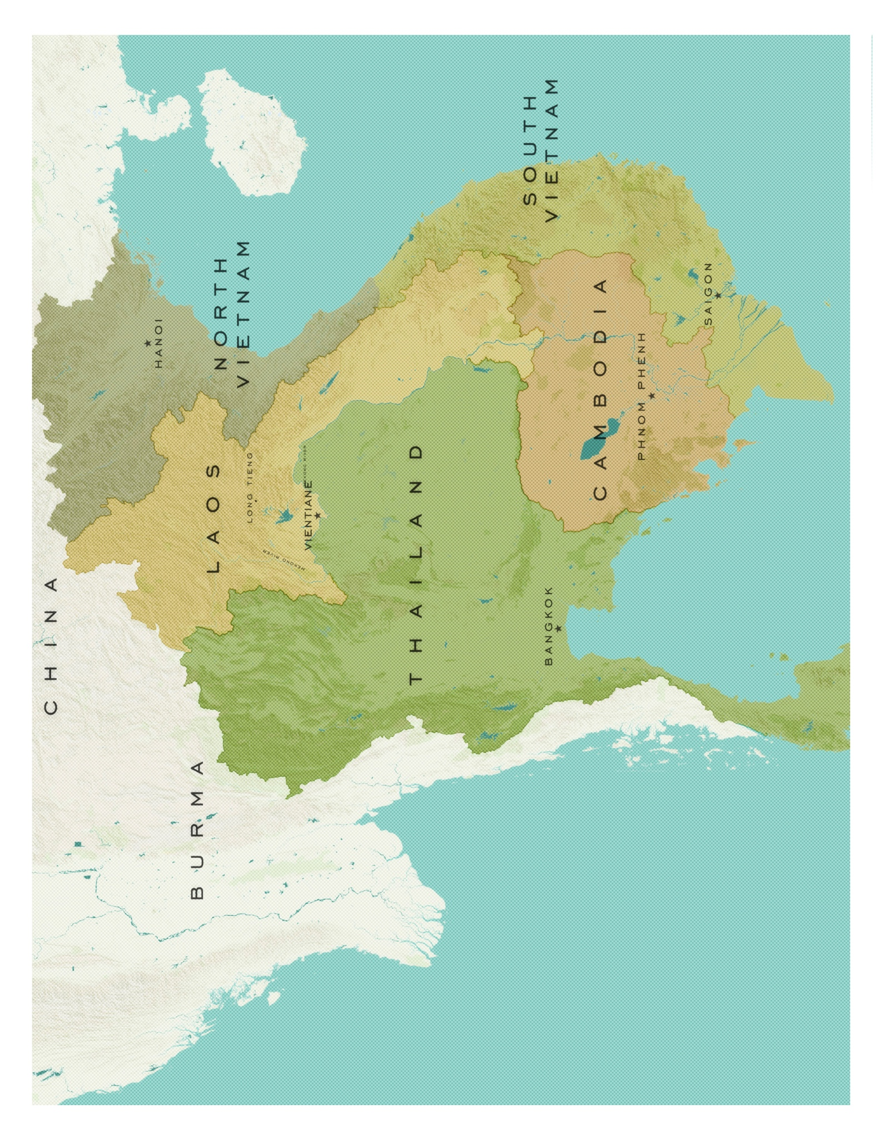

Handout A

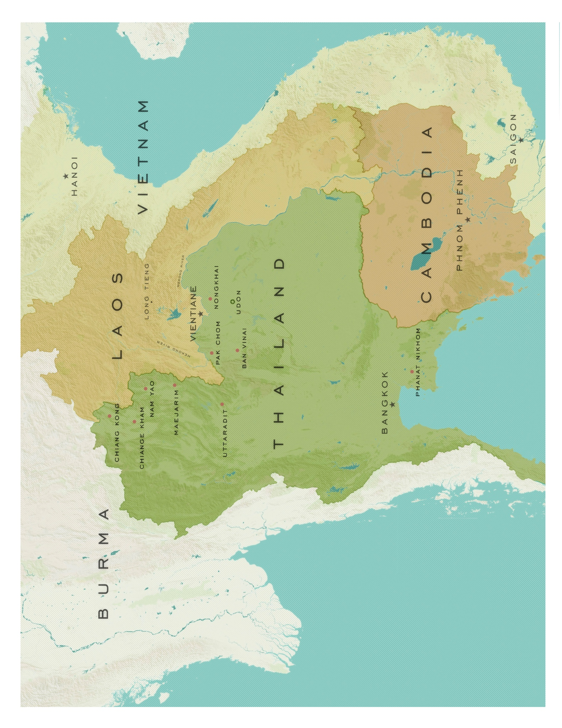

Handout B



Handout C



Handout D

Handout E

HANDOUT B- Thai Refugee Camps Map

HANDOUT C- Interview Questions

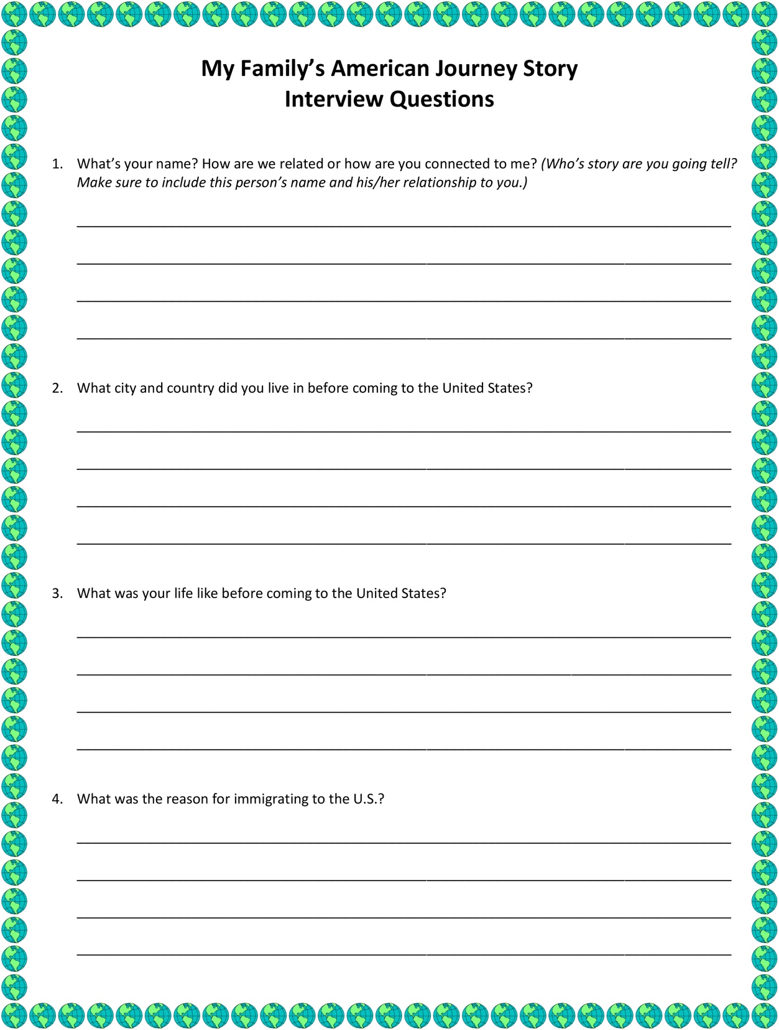

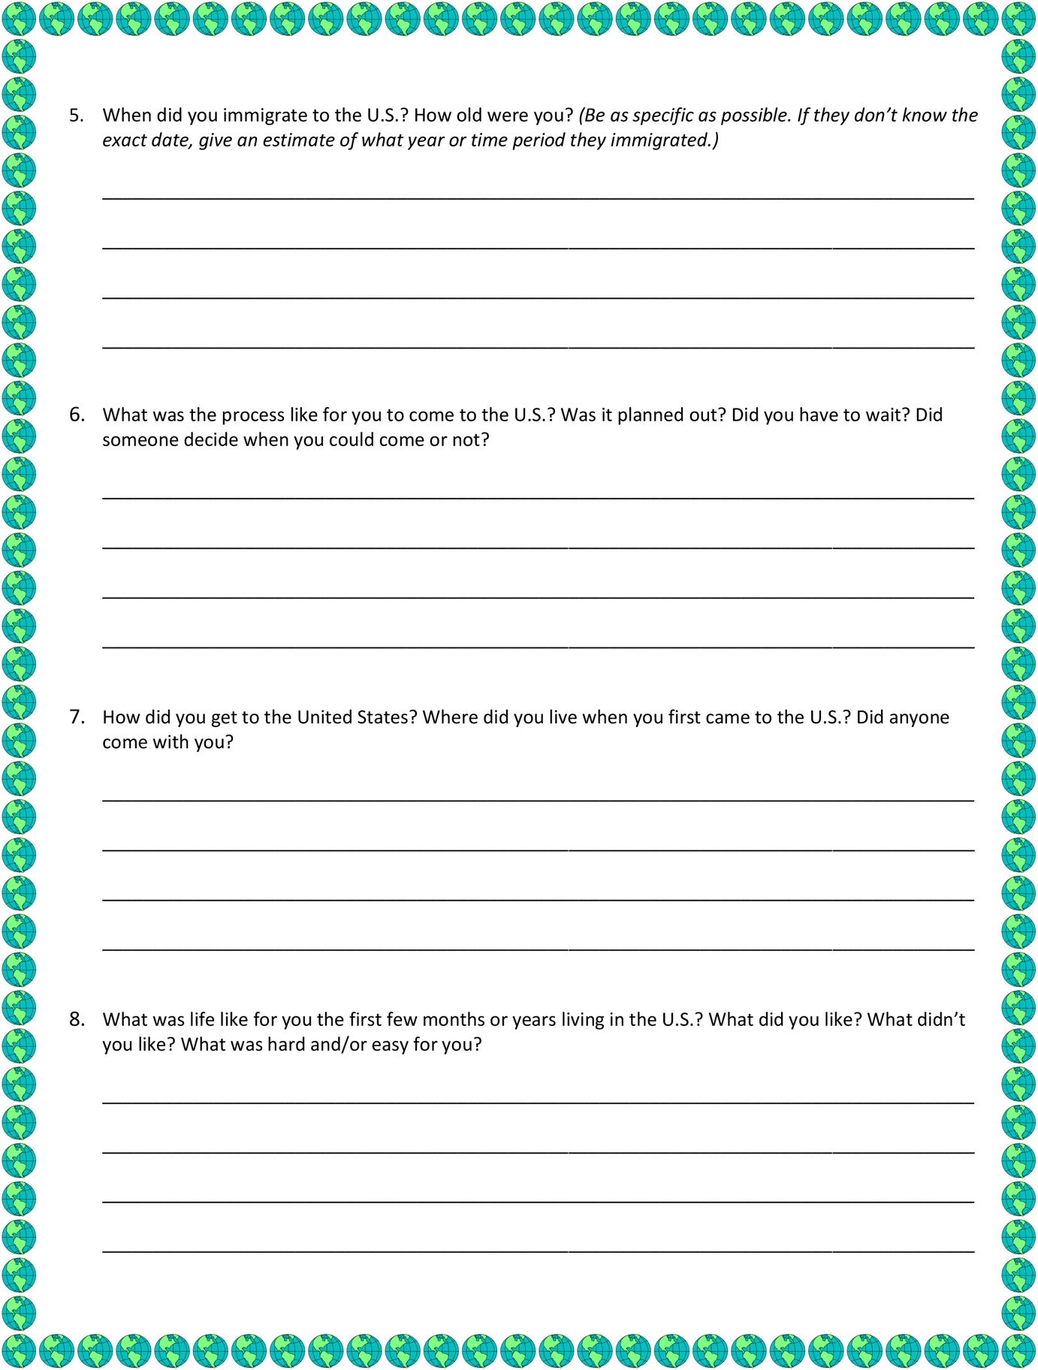

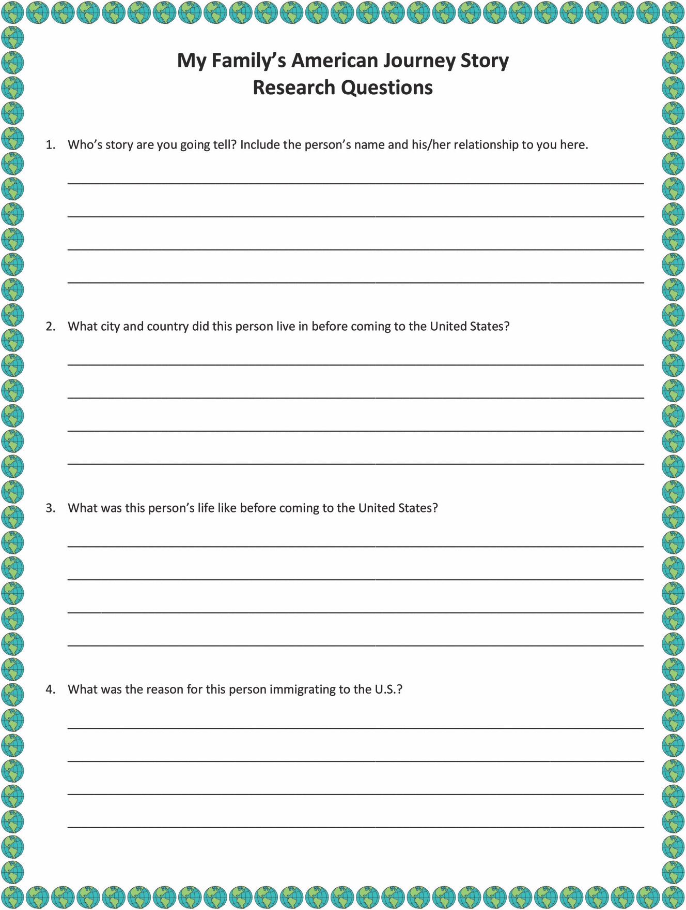

Handout F

HANDOUT D- Research Questions

